**What are Ball Screws?**

A Ball Screw is a mechanical linear actuator that translates rotation motion into a linear motion. To put it into perspective it’s essentially a rod that moves within a thread that spins and due to this rotational movement it can either move forward or backwards. With this in mind it’s important to note that due to this design there is very little friction due to the use of ball bearings hence the name Ball Screws. Due to this ball bearing design the tolerances are very little and can achieve situations that require very high precision. It is also an enclosed system that is self-lubricated, however needs to be serviced once in a while.

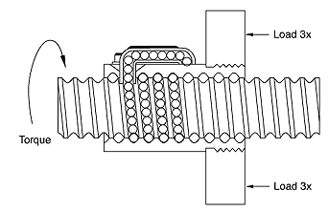EX Pic 1:

With this image in mind we have a basic understanding with Ball Bearing Screws.

**Equations**

$$T=\frac{Fl}{2πv}$$

T= Torque applied to Screw or Nut

F= Linear Force Applied

l= Ball Screw Lead

v= Ball Screw Efficiency

**NSK Ball Screw Types Available**

* Compact FA Series – High Speed, Low Noise operation in a compact design. Ranges 10mm to 25mm and low profile.
* A-Series & S-Series
* NTF-SRC Series
* V1 BBS Series
* MHC Series
* High Speed SS Series

Rough Length Needed 1200mm

The CNC Lathe needs to have .05mm accuracy

By: Alex Rubtsov

Reference:

* <https://en.wikipedia.org/wiki/Ball_screw>
* <http://www.barnesballscrew.com/how-a-ball-screw-works/>
* http://www.nskamericas.com/cps/rde/xchg/na_en/hs.xsl/ballscrews.html